

Steel Manufacturing Defects
Submitted in partial fulfillment of the requirements of the degree of Bachelors of Technology in Information Technology
By
Sakina Mala
Pranjal Parmar
Keyush Thumar

Supervisor
Dr. Mansing Rathod


DEPARTMENT OF INFORMATION TECHNOLOGY
K.J. SOMAIYA INSTITUTE OF TECHNOLOGY, AYURVIHAR, SION, MUMBAI-22
2024-2025



CERTIFICATE
This is to certify that the project entitled “STEEL MANUFACTURING DEFECTS” is a Bonafide work of students Sakina Mala, Pranjal Parmar, Keyush Thumar submitted to University of Mumbai in partial fulfillment of the requirement for the award of the degree of Bachelor of Technology in Information Technology.

Dr. Masing Rathod
Project Guide
Department of Information Technology

Dr. Radhika Kotecha Dr. Vivek Sunnapwar
Professor, Principal
Head of Department

Place: Sion, Mumbai-400022

Date:

Project Report Approval for B.Tech.
This project report entitled “Steel Manufacturing Defects” by
Sakina Mala (13)
Pranjal Parmar (18)
Keyush Thumar (33)

is approved for the degree of Bachelor of Technology in Information Technology.

Examiners:
1. __________________

2. __________________
Date:
Place: Sion, Mumbai-400022.

Declaration
We declare that this written submission represents our ideas in our own words and where others' ideas or words have been included, we have adequately cited and referenced the original sources. We also declare that we have adhered to all principles of academic honesty and integrity and have not misrepresented or fabricated or falsified any idea/data/fact/source in our submission. We understand that any violation of the above will cause disciplinary action by the Institute and can also evoke penal action from the sources which have thus not been properly cited or from whom proper permission has not been taken when needed.

Sakina Mala

Pranjal Parmar

Keyush Thumar

Date:
Place: Sion, Mumbai-400022

ACKNOWLEDGEMENT

We would like to convey our sincere thanks to everyone who guided us throughout this project endeavor, before we present our project entitled “Steel Manufacturing Defects”.
We wish to express our sincere thanks to Dr. Vivek Sunnapwar, our Principal, for providing us with all the necessary facilities for the research.
We place on record our sincere thank you to Dr. Radhika Kotecha, Head of Department for the continuous encouragement.
We are also grateful to Dr. Mansing Rathod, Project Supervisor. We are extremely thankful and indebted to his for sharing expertise, and sincere and valuable guidance and encouragement extended to us.
We take this opportunity to express gratitude to all the Department faculty members for their help and support. We also thank our parents for unceasing encouragement, support and attention.

Sakina Mala

Pranjal Parmar

Keyush Thumar

Date:

ABSTRACT

The combination of changes in raw materials, procedures and even the environment increases the difficulty of ensuring product quality in a steel production business. This very phenomenon leads to common flaws such as fractures, inclusions, and inconsistent thickness. Anomalies of this nature go unnoticed with standard inspection and statistical encapsulation which further decreases efficiency and profitability. These issues introduce a qualitatively burdensome amount of rework, decay of resources, and disruption of production. To accurately detect, predict, and mitigate production flaws in steel, this study offers a model-based approach, including ResNet50, ResUNet, and Convolutional Neural Networks (CNN), integrating AI and ML. The system continuously scans the processes for temperature, pressure, and material composition and identifies deviations from set norms, actively anticipating errors before they occur. Combining machine learning, artificial intelligence, and image segmentation serves to improve operational and product reliability by shifting from traditional reactive quality control policies to proactive maintenance and optimization. This, in turn, leads to remarkable improvements in operational efficiency.

Keywords: Maintenance, efficiency, optimization.

TABLE OF CONTENTS

Chapter No | TITLE | Pg No
1 | INTRODUCTION | 1
 | 1.1 Motivation | 2
 | 1.2 Scope | 2
 | 1.3 Objectives | 3
 | 1.4 Significant Contributions | 3
 | 1.5 Organization of Report | 3
2 | RELATED WORK | 5
 | 2.1 Review of Literature | 6
 | 2.2 Related Applications | 9
3 | ANALYSIS AND PLANNING | 11
 | 3.1 Feasibility Study | 12
 | 3.2 User Characteristics | 12
 | 3.3 Assumptions and Dependencies | 12
 | 3.4 Functional Requirements | 12
 | 3.5 Non-functional Requirements | 13
 | 3.6 Interface Requirements | 13
 | 3.7 Project Scheduling | 14
4 | PROPOSED WORK | 15
 | 4.1 Approach | 16
 | 4.2 Use Case Diagram | 17
 | 4.3 Activity Diagram
 | 4.4 Sequence Diagram | 18
 | 4.5 Product Cost and Expenses | 18
5 | IMPLEMENTATION DETAILS AND RESULTS | 20
 | 5.1 Implementation Details | 21
 | 5.2 Results and Discussion | 26
 | 5.3 Impact Analysis | 34
 | 5.4 Sustainability and Scalability Analysis | 34
6 | CONCLUSION AND FUTURE WORK | 36
 | 6.1 Conclusion | 37
 | 6.2 Future Work | 37
7 | REFERENCES | 38
 | PUBLICATIONS AND CERTIFICATES | 41
 | PLAGIARISM REPORT | 42

List of Abbreviations

- R&D – Research and Development
- AI-ML – Artificial Intelligence and Machine Learning
- ResNet50 – Residual Network 50
- ResUNet – Deep Residual U-net
- CNN – Convolutional Neural Network
- RLE – Run Length Encoding

List of Figures
Figure No. | Title | Page No.
Figure 3.7.1 | Project Timeline | 14
Figure 4.1.1 | Proposed approach of project | 16
Figure 4.2.1 | Use Case Diagram | 17
Figure 4.3.1 | Activity Diagram
Figure 4.4.1 | Sequence Diagram | 18
Figure 5.1.1 | Showcasing images with defect | 21
Figure 5.1.2 | Highlighting the defect area | 21
Figure 5.2.1 | Visualization of comparison of models | 28
Figure 5.2.2 | Accuracy based comparison | 29
Figure 5.4.1 | Sign Up Page | 30
Figure 5.4.2 | Login Page | 31
Figure 5.4.3 | About Us Page | 31
Figure 5.4.4 | Services Page | 32
Figure 5.4.5 | Contact Us Page | 32
Figure 5.4.6 | Detecting Steel as Non-Defective Page | 33
Figure 5.4.7 | Detecting Steel as Defective Page | 33

List of Tables
Table No. | Title | Page No.
Table 2.1.1 | Literature Review | 7
Table 5.2.1 | Classification Report of RestNet50 Model | 27
Table 5.2.2 | Classification Report of ResUNet Model | 28
Table 5.2.3 | Classification Report of CNN Model | 28

CHAPTER 1

INTRODUCTION

Introduction

In the highly competitive world of steel manufacturing, the winning card for cost economies and quality retention rests with effective use of resources and subsequent operational productivity. While steel is being produced, material defects such as inclusions, splits, and unevenness of cross-sections may arise at different stages. If undetected in time, these imperfections directly negatively influence the overall profit by causing excessive waste, rejected products, or R&D that is far more costly than necessary. The capacity of conventional defect detection strategies, which rely on manual scanning and passive quality assurance processes, is extremely limited for the detection of minute defects, and even more so, they are terribly slow. This oversights far too many imperfections in the product until later in the cycle or even post-delivery to the client’s premises and in turn increases spending, frustrates clients, and ultimately tarnishes the supplier’s image.
This investigates the challenges that are outlined can be effectively solved through the use of modern advancements in ML and AI. In real-time analysis of massive volumes of image data can aid in the automation of defect detection systems, allowing fine examinations to be performed in seconds. The AI system set in place can be trained using labeled datasets of correct and faulty images. These datasets enable the system to learn patterns and outliers that an average human inspector would normally miss. If these systems are fed enough data, they will be able to find, classify, and pinpoint the exact location of an error. This strategy alone greatly reduces the cost and result when paired with examining new ways to better maintain an organization’s expenses, waste, and down time.

1.1 Motivation:
The motivation for implementing an AI and ML-based defect detection system in steel manufacturing stems from its potential to significantly enhance product quality, reduce costs, and boost operational efficiency. By accurately identifying and predicting defects, manufacturers can minimize waste, rework, and resource consumption, directly lowering production costs. This proactive approach to defect management leads to superior steel products, which increases loyalty and customer satisfaction, while also driving potential growth in sales due to improved market reputation. Moreover, AI-driven systems excel in detecting patterns and anomalies that human inspectors may overlook, optimizing production processes and reducing downtime. By enabling more efficient use of resources and minimizing interruptions, manufacturers can streamline operations and improve overall productivity. This technological advancement offers a competitive edge, positioning companies as leaders in innovation and attracting new customers.

1.2 Scope
The scope of this project focuses on developing an AI and ML-based system capable of accurately detecting and classifying defects in steel products by analyzing images. The system will be trained on a comprehensive dataset of defect and non-defect images, enabling it to learn and differentiate between various defect types with maximum accuracy. An admin interface will allow users to upload new images, which the system will analyze to determine the presence of defects, providing detailed outputs on the type and location of any detected issues. Additionally, the system will continuously improve its accuracy by incorporating new data for retraining, ensuring adaptability to evolving production conditions. By automating the defect detection process, the project aims to enhance quality control, reduce human error, optimize production efficiency, and ultimately minimize operational costs for steel manufacturers.

1.3 Objectives
- Develop an AI and ML-based system that can accurately classify defects and non-defects in steel products by training on a large dataset of labeled images.
- Enable an admin to upload images of steel products for automated defect detection through an intuitive user interface.
- Implement a model that analyzes uploaded images and generates a clear decision on whether a defect is present or not, with high accuracy.
- Provide detailed information on the detected defects, including the exact location and type of defect, to assist in efficient quality control and corrective action.
- Enhance the operational efficiency of the steel manufacturing process by reducing human intervention, improving defect detection rates, and minimizing inspection time.

1.4 Significant Contributions
The project addresses the critical challenges in the steel manufacturing process by implementing advanced AI and machine learning models — specifically ResNet50, CNN, and ResUNet architectures — to automate and enhance defect detection. Unlike traditional manual inspections and static quality controls, our system processes thousands of images in real-time to accurately identify defects such as cracks, inclusions, and thickness variations with high precision. By enabling early and consistent defect detection, our solution minimizes human error, reduces inspection times, and significantly lowers operational costs by preventing extensive rework and downtime. Furthermore, by integrating predictive analytics, the project not only identifies existing defects but also anticipates potential production issues, leading to proactive process optimization. This innovation enhances overall product quality, boosts production efficiency, and supports sustainable manufacturing practices in the steel industry.

1.5 Organization of Report
The report is divided into 5 parts: -
- Literature Review: - This section provides an overview of the existing research on Steel Manufacturing Defects. It includes a review of the different approaches, techniques, and models used in previous studies, as well as an analysis of their strengths and weaknesses.
- Analysis and Planning: - This section discusses our analysis of the current state of manufacturing detection research and identifies any gaps or limitations in existing approaches. Based on this analysis, we can plan our proposed work by outlining your research questions, hypotheses, and objectives
- Proposed Work: - This section provides a detailed description of our proposed work, including the methodology and approach planned to use to Steel Manufacturing Defects. We described the dataset we used and all the preprocessing steps necessary to prepare the data for analysis.
- Implementation: - This section provides a detailed description of the implementation work, including the results and steps to how to use Steel Manufacturing Defects product. We described the flow of the product and its processed framework for the implementation.
- Conclusion: - Finally, we can summarize our findings and conclusions from your research on Steel Manufacturing Defects. This section highlighted the significance of our work and its potential impact on the field of Steel Manufacturing Defects. We can also suggest future research directions and areas for improvement in Steel Manufacturing Defects.

CHAPTER 2

RELATED WORK

2.1 Review of Literature
Research on steel manufacturing defect detection has identified several limitations that impact model performance and applicability. Many studies rely on relatively small datasets, which may not fully represent real-world conditions. This insufficiency can lead to challenges in accurately identifying defects, particularly when dealing with low-contrast images and complex backgrounds. As a result, these factors may hinder the effectiveness of defect detection systems and compromise the overall quality of inspections.

Another significant challenge in the existing literature is the high computational demand associated with certain models, such as RetinaNet. These requirements can limit the practicality of implementing such models in real-time applications, where speed and efficiency are critical. Furthermore, many existing methods struggle with multi-level defect categorization, complicating the identification of varying defect types and their severity. This issue underscores the necessity for more robust approaches that can address diverse defect categories effectively.

Additionally, the "black-box" nature of Convolutional Neural Networks (CNNs) poses a significant barrier to understanding and explaining their decision-making processes. This lack of transparency is critical for industrial adoption, as manufacturers often require clear insights into how models arrive at their conclusions. Incorporating Explainable AI techniques can enhance interpretability, fostering trust in these systems. Addressing these challenges is vital for advancing defect detection methodologies and improving quality control in steel manufacturing.

Recent advancements in steel defect detection heavily leverage deep learning and machine vision techniques. Zhao et al. [11] introduced a novel steel defect detection algorithm utilizing deep learning, while Li et al. [12] enhanced YOLOv3 for more accurate strip steel surface defect detection. Similarly, Li et al. [13] proposed an online metallic surface defect detection method tailored for wire arc additive manufacturing. Comprehensive reviews by Saberiranjbar et al. [14] and Tang et al. [15] discussed various deep learning and machine vision approaches for defect detection in industrial products and steel surfaces, respectively. Though primarily focused on medical imaging, Abhisheka et al. [16] provided insights into deep learning methods that parallel defect classification techniques. Newton et al. [17] explored non-destructive evaluation methods like eddy current testing, applicable to surface assessments. Singh and Desai [18] developed an automated defect detection framework combining machine vision and CNNs. Gao et al. [19] proposed a semi-supervised CNN-based approach for recognizing steel surface defects, and Bodrovskiy et al. [20] presented YOLO4, balancing speed and accuracy for object detection tasks relevant to industrial applications.
Table 2.1.1: Literature review

Paper Title | Year | Key Takeaways | Limitations
Steel Plate Surface Defect Detection Method Based on Improved YOLO Algorithm.^{[1]} | 2023 | The original YOLOv5 and the proposed algorithm detect typical steel plate surface defects, but missed detections may occur when defects closely resemble the background or are adjacent to each other. | The NEU-DET dataset may lack diversity for generalization, while environmental factors, hardware constraints, and scalability challenges can affect performance and applicability in large production settings.
Improved Deeplabv3+ Based Steel Surface Defect Segmentation.^{[2]} | 2024 | Traditional CNNs may lose important spatial information during pooling, but the system extracts dense feature maps to improve pixel classification and segmentation of small steel defects. | The model's performance is evaluated on specific types of steel surface defects (scratches, inclusions, and patches). Its effectiveness in generalizing to other types of defects or surface conditions is not discussed.
Inception V3 Model-based Approach for Detecting Defects on Steel Surfaces.^{[3]} | 2024 | The Inception V3 model detects diverse steel surface defects like scratches, cracks, and rust, adapts to varying surface conditions, and is compared with other CNN architectures for defect detection tasks. | The limited dataset for training lacks enough samples for successful generalization, accurately detecting common defects like corrosion and scratches, while less common defects may be overlooked.
Steel Sheet Defect Detection using Feature Pyramid Network and RESNET.^{[4]} | 2022 | The proposed system utilizes a steel sheet defect dataset, employing a Feature Pyramid Network to select multiple defect features and ResNet to classify overlapping defects, aiding in the identification of single steel sheets to minimize losses and reduce defects. | Model’s Evaluation Metrics while training the model and accuracy dependencies of all the model’s trained is too less and not to be considered as a perfect model fit.
Deep Learning-  Based Defect Detection System in Steel Sheet Surfaces.^{[5]} | 2020 | The study improves steel defect inspection using U-NET and Deep Residual U-NET, achieving Dice coefficients of 0.543 and 0.731, respectively, with Deep Residual U-NET outperforming U-NET in detecting multiple defects. | The dataset, though substantial, may not fully represent all steel sheet defects, while the complex Deep Residual U-NET models require significant computational resources, and their generalization to other defect types or materials remains unaddressed.
A Fast Method of Steel Surface Defect Detection Using Decision Trees Applied to LBP based Features.^{[6]} | 2011 | The paper presents a method for steel surface defect detection using decision trees, enhancing accuracy with PCA and Bagging on LBP-extracted features, leading to faster, more accurate real-time inspection. | The paper notes that decision trees exhibit moderate performance compared to Support Vector Machines (SVMs) due to lower accuracy and high variance, which can cause instability in classification results.
Steel Surface Defect Detection Using Texture Segmentation Based on Multifractal Dimension.^{[7]} | 2009 | The paper underscores the need for quality control in steel manufacturing and proposes multifractal dimension techniques for accurately detecting defects on irregular shapes. | Real-time implementation may face challenges due to high-speed processing needs, while adaptability to different steel surfaces and the computational intensity of feature extraction could impact system efficiency.
Steel Defect Detection using High Frequency Cameras.^{[8]} | 2022 | The research targets steel manufacturing defect detection using high-frequency cameras and machine learning models, proposing methods like RetinaNet and FPN to enhance precision and speed. | Data insufficiency for defects beyond Type 3, high computational demands of models like RetinaNet, and challenges in multi-level defect categorization hinder its effectiveness.
Detection of Manufacturing Defects in Steel Using Deep Learning With Explainable Artificial Intelligence.^{[9]} | 2024 | The study employs deep learning models, including U-Net and FPN with backbones like ResNet, InceptionV3 and EfficientNet, while integrating Explainable AI techniques such as GradCAM, SHAP, and LIME for transparency in decision-  making. | The study highlights limitations from small datasets, challenges in low-contrast images and complex backgrounds for defect identification, and the "black-box" nature of CNNs that hinders understanding and industrial adoption.
Fast vision-based surface inspection of defects for steel billets.^{[10]} | 2016 | The method relies on simple pixel-domain vision-based operations to achieve rapid and accurate inspection. The framework effectively detects corner and sponge cracks on steel billets, demonstrating good inspection accuracy through experimental results. | The current framework primarily focuses on detecting corner and sponge cracks, which may not cover all possible defect types in steel billets. The effectiveness of the vision-based system might be affected by varying environmental conditions such as lighting and surface contamination.

2.2 Related Applications:

2.2.1 Landing AI -
Landing Through its flagship platform, LandingLens, AI is a company dedicated to delivering AI-driven solutions to sectors such as manufacturing, electronics, agriculture, and automotive. With minimal technical overhead and high accuracy, LandingLens is a cloud-based computer vision tool that helps businesses create, refine, and implement AI models. The platform provides an easy-to-use method for developing automated visual inspections that detect product flaws or irregularities, which is especially helpful for quality control in manufacturing settings. Applications where labeled data is scarce, like industrial material defect detection, can benefit from the solution's efficient handling of complex and small datasets.

2.2.2 Smart Manufacturing Systems with Real-Time Detection -
In conjunction with Internet of Things (IoT) devices, contemporary smart manufacturing systems use DL techniques to detect defects in real-time. Real-time production line monitoring enables these systems to promptly detect flaws and notify operators, reducing waste and enhancing production effectiveness. These systems frequently make use of lightweight algorithms designed for high-speed analysis, making them ideal for high-volume settings where prompt inspection is essential, such as steel manufacturing.

2.2.3 Deep Learning for Material Defect Detection (MDD) -
In order to identify distinct flaws like corrosion, porosity, and cracks on metal surfaces, a variety of algorithms—from basic classifiers to sophisticated neural networks—are used in the specialized field of machine learning-driven defect detection. In sectors like aerospace and automotive manufacturing that demand a high degree of precision, MDD technologies are frequently used for quality control. These systems use neural networks to extract high-level features, which enables precise and instantaneous defect detection, even on intricate and sizable datasets.

2.2.4 Automated Optical Inspection (AOI) with Deep Learning Models -
Cameras and deep learning algorithms are combined in Automated Optical Inspection (AOI) systems to find flaws in a variety of materials, including metal surfaces. Convolutional Neural Networks (CNNs) and transfer learning models such as VGG-16, ResNet-50, and MobileNet are used in many systems because they are capable of accurately classifying images based on flaws found on flat and cylindrical metal surfaces. Although these models are very successful, they need a lot of data to function at their best. High accuracy of up to 99.83% has been demonstrated by advanced models trained with frameworks such as AutoKeras, highlighting the importance of automated machine learning (AutoML) in enhancing defect detection and reducing human error.

CHAPTER 3

ANALYSIS AND PLANNING

3.1 Feasibility Study:

Technical Feasibility
- The project uses widely available tools like Python, TensorFlow, Keras, and Streamlit.
- Pre-trained models such as ResNet50 enable faster development and improved performance.
- Deployment via Streamlit allows for easy visualization and accessibility.

Operational Feasibility
- The system aims to automate defect detection in images, reducing human effort and error.
- Streamlit UI provides an easy interface for end-users to upload images and view results instantly.

Economic Feasibility
- No licensing cost due to use of open-source tools.
- Resource-efficient — does not require heavy infrastructure if hosted on cloud or GPU-enabled environments.

3.2 User Characteristics:
- End Users: Quality inspectors, production engineers, or AI system operators.
- Technical Skills: Basic knowledge of image-based inspection systems, ability to use web applications.
- Expectations: A user-friendly interface with fast and accurate predictions of defects in images.

3.3 Assumptions and Dependencies:

Assumptions
- All input images are preprocessed to match the required resolution (256x256).
- The defective and non-defective labels in training data are accurate.
- Users will have a stable internet connection if deployed via a cloud platform.

Dependencies
- External libraries (TensorFlow, Keras, OpenCV, Pandas, etc.).
- Pre-trained ResNet50 weights from ImageNet.
- Proper structure and availability of training image folders and metadata CSV files.

3.4 Functional Requirements:
- The system shall allow users to upload an image for defect analysis.
- The system shall preprocess the image to match the input requirements of ResNet50.
- The system shall predict whether the image is Defective or Non-Defective.
- The system shall display the prediction results and classification confidence.
- The system shall allow visualization of prediction metrics (accuracy, precision, recall, etc.).
- The system shall store or log predictions (optional).

3.5 Non-Functional Requirements:
- The system shall respond to predictions within 3-5 seconds.
- The system shall achieve at least 85% accuracy in detecting defects.
- The system shall maintain a user-friendly and intuitive UI.
- The model shall be retrainable with new data in the future.
- The web app shall be accessible across desktop platforms (Windows, macOS, Linux).
3.6 Interface Requirements:

User Interface
- Upload Button for images.
- "Predict" button to trigger analysis.
- Display panel showing:
  - Prediction (Defective/Non-Defective).
  - Confidence Score.
  - Optionally, the input image alongside output.

Hardware Interface
- GPU support (optional but recommended for faster inference).
- Camera/device input interface optional.

Software Interface
- TensorFlow for loading the trained ResNet50 model.
- Streamlit and Django for web interface.
- File system access for image loading and preprocessing.
3.7 Project Scheduling
The project initiates with a comprehensive literature survey to build a strong understanding of the existing research landscape. After establishing a solid foundation, efforts are focused on working on research papers to contribute insights to the academic community. Parallelly, careful consideration is given to deciding on the most suitable technology stack, setting a clear path for development. With the groundwork laid, the project moves into the core technical phase, starting with the development of models such as ResUNet, CNN, and ResNet50. Simultaneously, work on developing the frontend begins, ensuring an intuitive and accessible user interface.

Once the initial model development and frontend creation are underway, the next step involves connecting the frontend with a backend database using SQLite, ensuring smooth and efficient data management. During this phase, work on refining the research paper continues in parallel. As the models evolve, efforts are dedicated to enhancing their accuracy to achieve optimal performance. In addition, the frontend is updated to integrate outputs from the ResNet50 model, ensuring that the system works seamlessly end-to-end and leverages the latest model improvements.

The project concludes with the finalization of all features and functionalities, followed by the publication of the research paper. This marks the successful completion of both the technical development and academic contribution, delivering a well-rounded and impactful outcome.

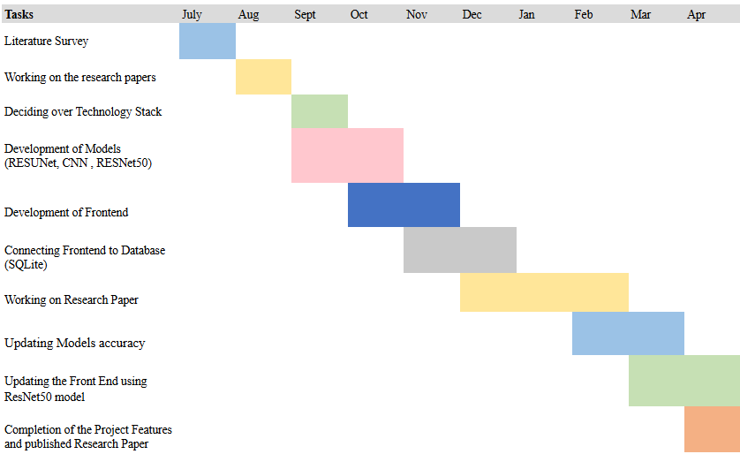
Fig 3.7.1 - Project Timeline
CHAPTER 4

PROPOSED WORK
4.1 Approach:
The steel manufacturing industry, despite being a critical component of global infrastructure, faces significant challenges in maintaining product quality and minimizing defects during production. Variations in raw material properties, complex manufacturing processes, and environmental factors often lead to defects such as cracks, inclusions, and inconsistencies in thickness. These defects not only result in product rejections and costly rework but also disrupt production schedules and waste valuable resources. Moreover, traditional defect detection methods, reliant on manual inspections and statistical process controls, often fail to catch all anomalies, leading to operational inefficiencies and reduced profitability. In response to these challenges, this paper proposes an AI and ML-based solution designed to accurately identify, predict, and minimize defects in steel manufacturing processes.

By leveraging advanced machine learning algorithms, computer vision techniques and real-time data analytics, the system aims to continuously monitor critical parameters, detect deviations in real time, and predict potential defects before they occur. The integration of AI/ML into the steel production line will enable a proactive approach to quality control, shifting from reactive defect management to predictive maintenance and optimization. The proposed solution utilizes a vast array of data from various sensors, including temperature, pressure, and material composition, to train models that learn from historical defect patterns and operational conditions.

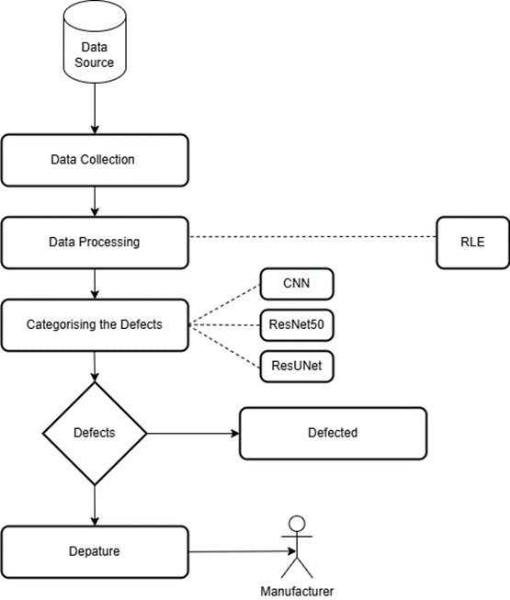
Fig 4.1.1 Proposed approach of project
Figure 4.1.1 is a proposed approach of system which shows that it collects data from the source which consists of 12,997 steel images so that it can categorize and detect which images are defective and non-defective. Hence, the product is then made based on this large dataset. Image is classified into two classes - defective and non-defective with the help of CNN Model, then image is segmented with the help of ResUNet Model after which image is detected defective and non-defective with the help of ResNet50 Model. In this process Image Processing and Image Segmentation using RLE(Run Length Encoding) has been performed. After detection has been performed successfully, it is then used by manufacturers.

4.2 Use Case Diagram
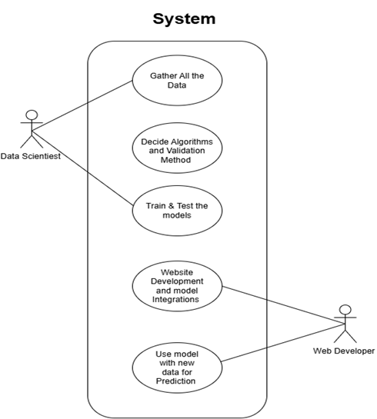
Fig 4.2.1 - Use Case diagram

Figure 4.2.1 is the use case diagram that illustrates the workflow of a system where both a Data Scientist and a Web Developer collaborate. The Data Scientist is responsible for gathering the data, selecting appropriate algorithms and validation methods, and training and testing the models. Once the models are prepared, the Web Developer handles website development and integrates the models into the system. Finally, the integrated system is used for making predictions on new data. This structure clearly defines the roles and collaboration needed to successfully deploy a machine learning model into a web application.
4.3 Activity Diagram
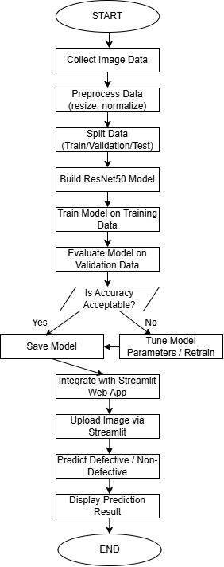
Fig 4.3.1 – Activity Diagram

Figure 4.3.1 is the activity diagram that illustrates the workflow of an automated defect detection system. It begins with image data upload and preprocessing, followed by training the ResNet50 model. After training, the model classifies new images as defective or non-defective. Defective items are flagged for review, while non-defective ones proceed to dispatch. Model evaluation ensures continuous performance improvement.

4.4 Sequence Diagram

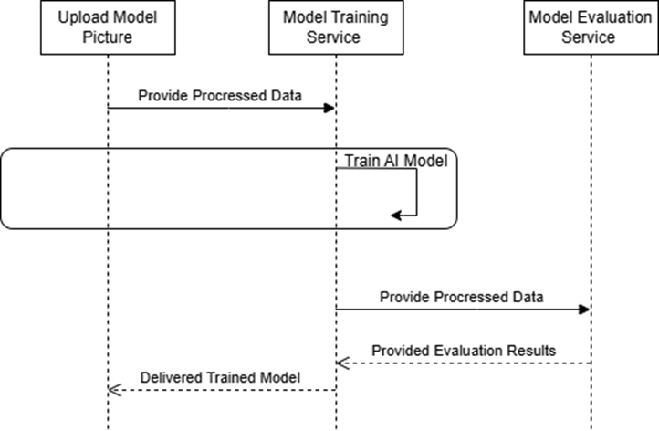
Fig 4.4.1 - Sequence diagram
Figure 4.3.1 is the sequence diagram which depicts the workflow of an AI model training and evaluation system. Initially, a model picture is uploaded, and the processed data is sent to the Model Training Service. The service trains the AI model and sends the processed data to the Model Evaluation Service for performance assessment. After evaluation, the results are sent back, and the final trained model is delivered. This flow ensures that the model is both accurately trained and properly evaluated before deployment.

4.5 Product Expenses
- Development Costs:
- AI/ML Model Development: Expenses related to hiring or allocating AI/ML engineers for developing deep learning models (ResNet50, CNN, ResUNet) for defect detection.
- Web Dashboard and Interface Design: Designing an intuitive dashboard for displaying real-time defect detection results, requiring expertise of frontend/ backend developers and UI/UX designers.
- Server Infrastructure:
- Cloud Hosting: Using cloud platforms (AWS, Google Cloud, Azure) for model training, data storage (13,000 images), and hosting the defect detection system, with costs depending on compute usage, storage, and bandwidth.
- Operational Expenses:
- Maintenance and Model Updates: Regular updates of AI models to improve accuracy, periodic retraining with new data, and backend maintenance to ensure system reliability.
- Technical Support: Providing support to factory teams or operators using the system, including issue resolution, guidance, and system monitoring which requires dedicated support personnel.
- Marketing and Promotion:
- Promotional Materials: Expenses for creating brochures, videos, and digital content to showcase the solution to steel manufacturing companies, quality control heads, and investors.
- Sales and Outreach: Costs related to demonstrating the defect detection system to factories, participating in industrial expos, networking events, and business outreach activities.

CHAPTER 5

IMPLEMENTATION DETAILS AND RESULTS
5.1 Implementation Details
Dataset consists of 12,997 images out of which 7,095 have defects, while 5,902 are non-defective. There are 5201 images with a single defect, 272 images with two defects and only one image with three defects.
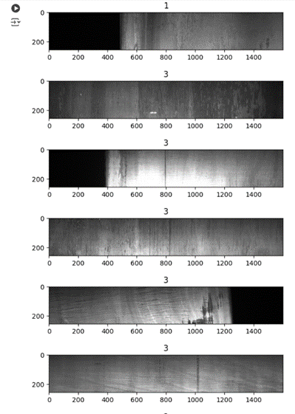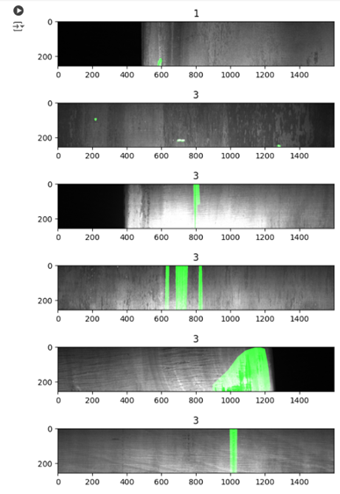
Fig 5.1.1 - Showcasing images with defect Fig 5.1.2 - Highlighting the defect area

Figures 5.1.1 and 5.1.2 display randomly selected defect images which highlight defective areas using image segmentation and calculating the subnet mask respectively.

1. Details of Software Used
(a) ResNet50 Model: Residual Network 50 is a 50-layer deep convolutional neural network. Because of its remaining connections, the model can "skip" some levels and transfer data straight between them. As ResNet50 can learn intricate features and perform well on large image datasets, which has then emerged as one of the most widely used models for image identification applications. It is a dependent option which can precisely detect the defect classification and identification, even in difficult dataset that consists of noise or complicated textures, because of its strength in generalizing well across different defect kinds.
Mathematical Representation:
X: Input Image;
F_{ResNet50}(X): Features that are extracted by the ResNet50 model;
GAP(F_{ResNet50}(X)): Global Average Pooling which is applied to the ResNet50 output; FC₁(GAP(F_{ResNet50}(X))): It is a first dense layer with ReLU activation;
FC₂(FC₁(GAP(F_{ResNet50}(X)))): It is an output dense layer with sigmoid activation.
Output Y is shown as:
Y = σ(W₂ ⋅ ReLU(W₁ ⋅ GAP(F_{ResNet50}(X)) + b₁) + b₂)
σ: Sigmoid activation function that is used for binary classification;
W₁,b₁: Biases and weights of a first dense layer;
W_{2,}b₂: Biases and weights of a final dense layer;
ReLU: Activation function used in the first dense layer; GAP: Global Average Pooling applied to the features extracted by the ResNet50 model.

(b) ResUNet Model: It is a combination of ResNet and UNet architectures which combines best features of both models that makes it more effective for jobs requiring accurate object segmentation and localization inside the images. On the contrary to UNet, a convolutional neural network has been created specifically for biomedical image segmentation which is distinguished by its "U-shaped" structure that collects both high-level and low-level data and ResNet is renowned for its deep residual structure, which facilitates the effective learning of complex patterns. UNet operates as the decoder in this combination which concentrates on recreating the image's spatial information, while ResNet operates as the encoder to collect significant feature representations.
Mathematical Representation:
Input: X ∈ ℝ^{H×W×C} (H: Height, W: Width, C: Channels, typically C = 3 for RGB images)
Encoder Path - For each encoder block E_{i}:
E_{i} = ReLU(BN(Conv2D(F_{i−1}))) + ReLU(BN(Conv2D(MaxPool2D(F_{i−1}))))
F₀ = X, which is an Input Image;
MaxPool2D: Downsampled by a factor of 2;
E_{i}: It is an output feature map of encoder block i.
Bottleneck Layer - The representation of bottleneck layer B becomes:
B = ReLU(BN(Conv2D(MaxPool2D(E₃))))
Where E₃: Output of last Encoder block.
Decoder Path - For each decoder block D_{i}:
D_{i} = ReLU(BN(Conv2D([UpSample(D_{i+1}),E_{i}])))
UpSample: Up Samples by a factor of 2;
[⋅,⋅]: Channel-wise concatenation of the upsampled decoder output D_{i+1} and the encoder output E_{i}.
Final Output - The final layer plots the decoder ‘s output to single channel binary prediction:
O = Sigmoid(Conv2D(D₁))
O ∈ ℝ^{H×W×C}, represents segmentation mask.
(c) Convolutional Neural Network (CNN) Model: Deep learning uses CNN architectures for image recognition tasks because they are absolutely swift in categorizing different patterns in an image. CNNs with convolution and pooling layers are capable of detecting the edges, textures, and finer delicacies of an image. Hence, they are proficient in recognizing the spatial hierarchies in images. A CNN can be used as a benchmark model for defect identification on a dataset of pictures of steel products by classifying the images into different categories and defects. As a result, basic CNN structures are more efficient for automating simple defect recognition tasks, with the limitation of being outperformed by more complex ResNet models on subtle, sophisticated defect patterns.
Mathematical Representation:
Convolutional Layer (Conv2D) Operation - Each convolution operation comprises a feature map from an input image (or previous layer output) using a kernel (filter). The formula in general for a convolution operation for a single channel is:
$$y\left(k,l\right)=\sum_{i=0}^{M-1}{\sum_{j=0}^{N-1}{x_{k+i,l+j}}}⋅ w_{i,j}+b$$
y_{i,j} is the output pixel value of the feature map at position (i, j);
x_{i+m,j+n} is the value of input image at position (i+m, j+n);
w_{m,n} is the kernel weight;
b is the bias term;
M, N are the kernel height and width.
Max Pooling Layer-
$$y\left(k,l\right)=\sum_{i=0}^{M-1}{\sum_{j=0}^{N-1}{x_{k+i,l+j}}}⋅ w_{i,j}+b$$
R: It is a region (e.g., 2 $×$ 2 or 3 $×$ 3);
At position (i,j): y_{i,j} is the max pooled output value.
Fully Connected Layer (Dense) - After applying convolution and pooling layers, the feature maps are flattened into a 1D vector. The formula for a fully connected layer is given as:
z = W ⋅ x + b
z is an output of the layer;
W is a weight matrix;
x is an input (flattened feature map);
b is bias term.
Then, a non-linear activation (e.g., ReLU) is typically applied:
a = ReLU(z)
Where ReLU(z) = max(0, z).
Output Layer (Softmax for Classification) - For multi-class classification, the final output is usually calculated through a softmax function for the class probabilities:
$$P\left(y=d | x\right)= \frac{e^{z_{d}}}{{∑_{k}e}^{z_{k}}}$$
z_{c} is the output of the final layer for class c;
P(y = c|x) is the predicted probability for class x.
Cross-Entropy Loss (Objective Function) - The loss function for classification is cross-entropy loss, used in measuring the difference between the true label and the predicted class probabilities:
$$L= -\underset{c}{∑}y_{c}⋅log⁡(P(y=c|x))$$
y_{c} is the true label (1 if the class is correct, 0 otherwise);
P(y = c|x) is the predicted probability for class c.

(d) Django: Django is an open-source, high-level Python web framework that enables rapid development and clean, pragmatic design. It’s known for its "batteries-included" approach, offering built-in tools for handling common web development tasks like authentication, URL routing, and database management. Django is well-suited for creating complex web applications, and in the context of the defect detection system, it provides a solid foundation for building a robust, user-friendly interface where administrators can upload images, manage data, and view defect analysis results.

(e) SQLite: SQLite is a lightweight, serverless, self-contained SQL database engine that doesn’t require separate server processes, making it ideal for small to medium-sized applications. It’s easy to set up and is highly portable, as it stores data in a single file. For the defect detection system, SQLite serves as a backend database, managing records of uploaded images, defect analysis results, and other metadata. Its simplicity and efficiency make it a great choice for projects where scalability is not a primary concern.

(f) Image processing: Image processing is a method used to enhance or manipulate images using computer algorithms. It involves various techniques to improve image quality, extract useful information, or prepare images for analysis. Common tasks in image processing include filtering, edge detection, noise reduction, and image transformation. Applications span multiple fields, such as medical imaging, remote sensing, computer vision, and photography. By utilizing algorithms and tools, image processing enables automated analysis, pattern recognition, and feature extraction, making it essential in areas like facial recognition, object detection, and medical diagnostics.

(g) Google Colab: Google Colab, short for Colaboratory, is a cloud-based platform that allows users to write and execute Python code in a Jupyter notebook environment. It provides free access to powerful computing resources, including GPUs and TPUs, making it particularly popular for machine learning and data analysis tasks. Users can easily share notebooks with collaborators and access a wide range of libraries and datasets. Colab integrates seamlessly with Google Drive, enabling users to save their work and load data directly from the cloud. This ease of use and collaboration makes Google Colab an ideal tool for both beginners and experienced developers working on data science and machine learning projects.

(h) Visual Studio Code (VS Code): Visual Studio Code (VS Code) is a lightweight yet powerful source code editor developed by Microsoft, widely used for software development across various programming languages. It features a rich ecosystem of extensions that enhance its capabilities, including support for debugging, version control, and terminal integration. The editor offers intelligent code completion, syntax highlighting, and linting, which help developers write clean and efficient code. With its built-in Git support, developers can easily manage version control within the editor. VS Code's customizable interface and support for remote development make it a versatile choice for developers seeking a flexible and efficient coding environment.

(i) Libraries -
- pandas: A powerful data manipulation and analysis library for Python, providing data structures like DataFrames for handling structured data.
- numpy: A fundamental package for numerical computing in Python, offering support for arrays and a wide range of mathematical functions.
- seaborn: A statistical data visualization library based on Matplotlib, providing a high-level interface for drawing attractive and informative graphics.
- matplotlib.pyplot: A plotting library for creating static, animated, and interactive visualizations in Python, often used alongside NumPy.
- zipfile: A built-in Python library for reading and writing ZIP files, allowing for easy compression and extraction of files.
- cv2 (OpenCV): A library for computer vision tasks, providing tools for image processing, video capture, and machine learning.
- skimage (scikit-image): A collection of algorithms for image processing in Python, designed for image manipulation and analysis.
- tensorflow: An open-source machine learning framework developed by Google, widely used for building and training deep learning models.
- tensorflow.keras: A high-level neural networks API built on top of TensorFlow, making it easier to create and train deep learning models.
- IPython.display: A module providing functions to display rich media in Jupyter notebooks, including images, HTML, and LaTeX.
- sklearn.preprocessing: A module in scikit-learn that provides utilities for preprocessing data, including scaling and normalizing features.

  - Results and Discussions
1. Test Approach
The implementation parameters for enhancing steel defect detection through AI encompass various technical and operational considerations critical for the successful deployment and operation of the system. These parameters include:
- Algorithm Selection: The choice of machine learning models, including ResNet50, CNN, and ResUNet, plays a crucial role in the system's implementation. Each model's suitability for defect detection and its computational requirements must be carefully evaluated to ensure optimal performance in identifying steel defects.
- Data Preprocessing: The preprocessing techniques employed to clean and prepare the dataset significantly impact the accuracy and reliability of the models. Parameters such as handling missing or inconsistent data, normalizing features, and addressing class imbalances (if needed) must be defined and optimized to enhance data quality and model effectiveness.
- Model Training and Optimization: Parameters related to model training, such as hyperparameter selection and optimization techniques, are essential for maximizing the performance of the models. Techniques such as grid search with cross-validation and hyperparameter tuning are used to fine-tune each model and improve its accuracy, precision, and generalization capabilities.
- Infrastructure and Environment: The choice of programming language, development environment, and hardware infrastructure (e.g., cloud-based platforms or on-premises servers) are crucial implementation parameters. The system is implemented using Python within a suitable environment (such as Google Colab or local servers) with deep learning libraries like TensorFlow or PyTorch to facilitate model training and deployment.
- Monitoring and Maintenance: Parameters related to system monitoring and maintenance are essential for ensuring the ongoing reliability and effectiveness of the steel defect detection system. Proactive monitoring techniques, fault detection mechanisms, and predictive maintenance strategies are implemented to minimize downtime and maintain high system uptime.
- Evaluation Metrics: Parameters defining the evaluation metrics used to assess the system’s performance are critical for measuring its effectiveness in defect detection. Metrics such as precision, recall, F1-score and accuracy are computed to gauge the models' diagnostic capabilities and inform decision-making processes.
By defining and optimizing these implementation parameters, the system can be effectively deployed and operated to enhance defect detection in steel manufacturing through AI, ultimately improving quality control and operational efficiency.

2. Test Cases
Table 5.2.1 demonstrates the results classification report of all machine learning models for two classes which are 0 and 1. Overall, it can be said that ResNet50 model has successfully achieved an accuracy of 88% which demonstrates strong classification performance but imbalance in recall between two classes suggests that there is a potential trade-off between specificity and sensitivity which requires further need of optimization based on application's requirements and ResUNet model has achieved an accuracy of 76% which is comparatively lower than ResNet50 model's performance. The sharp difference in recall between two classes suggests that the model has favored detecting Class 1 over Class 0 which might require further tuning to balance sensitivity and specificity depending on this use case while the CNN model achieves an accuracy of 87% which reflects strong classification performance. The balance between precision, recall, and F1 scores across both classes indicates that CNN model performs well without significant bias toward one class which makes it a reliable choice for the given task.

Overall, the ResNet50 model achieves an accuracy of 88%, demonstrating strong classification performance. However, the imbalance in recall between the two classes suggests a potential trade-off between sensitivity and specificity, which may need further optimization based on the application's requirements.
Table 5.2.1 - Classification Report of ResNet50 model

Class | Precision | Recall | F1 - Score | Support | Accuracy
0 | 1.00 | 0.73 | 0.84 | 882 | 88
1 | 0.82 | 1.00 | 0.90 | 1054

Table 5.2.2 highlights the performance of the ResUNet model for the two classes, 0 and 1. For Class 0, the model achieved a precision of 0.90, indicating that most predictions for this class were correct. However, the recall is significantly lower at 0.52, meaning the model only correctly identified 52% of true instances for Class 0. This imbalance results in an F1 Score of 0.66. For Class 1, the model exhibits a lower precision of 0.71, reflecting the presence of false positives, but achieves a very high recall of 0.95, indicating that the majority of true instances were correctly identified. The F1 Score for Class 1 is 0.81, higher than that of Class 0.
Overall, the ResUNet model achieves an accuracy of 76%, which is comparatively lower than the ResNet50 model's performance. The sharp difference in recall between the two classes suggests that the model favors detecting Class 1 over Class 0, which may require further tuning to balance sensitivity and specificity depending on the use case.

Table 5.2.2 - Classification Report of ResUNet model

Class | Precision | Recall | F1 - Score | Support | Accuracy
0 | 0.90 | 0.52 | 0.66 | 1178 | 76
1 | 0.71 | 0.95 | 0.81 | 1422

Table 5.2.3 demonstrates the performance of the CNN model for the two classes, 0 and 1. For Class 0, the model achieved a precision of 0.88, indicating that most predictions for this class were accurate. The recall is 0.84, meaning the model correctly identified 84% of true instances for Class 0. This results in an F1 Score of 0.86, reflecting a balance between precision and recall. For Class 1, the model attained a precision of 0.87, with a slightly higher recall of 0.90, indicating that 90% of the true instances were correctly classified. The F1 Score for Class 1 is 0.89, which is slightly higher than for Class 0.
Overall, the CNN model achieves an accuracy of 87%, reflecting strong classification performance. The balance between precision, recall, and F1 scores across both classes indicates that the CNN model performs well without significant bias toward one class, making it a reliable choice for the given task.

Table 5.2.3 - Classification Report of CNN model

Class | Precision | Recall | F1 - Score | Support | Accuracy
0 | 0.88 | 0.84 | 0.86 | 879 | 87
1 | 0.87 | 0.90 | 0.89 | 1071

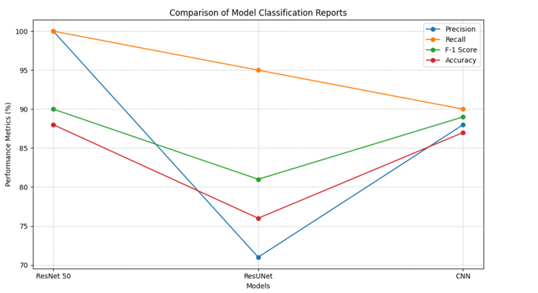
Fig 5.2.1 – Visualization of comparison of models

Figure 5.2.1 compares the classification performance of three models (ResNet50, ResUNet, and CNN) using four metrics: Precision, Recall, F1-Score, and Accuracy. ResNet50 demonstrates the highest precision and recall, while ResUNet shows lower performance across all metrics compared to the others. CNN achieves balanced metrics close to ResNet50.

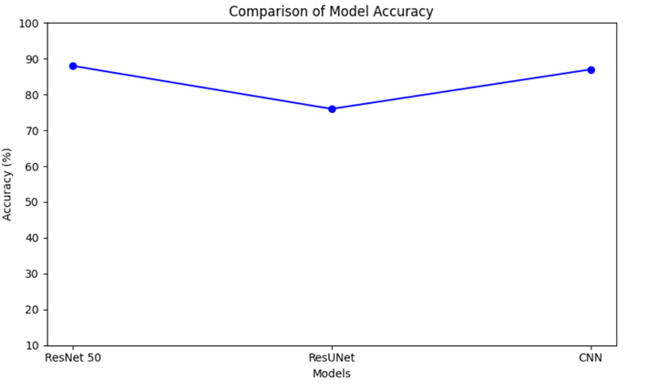
Fig 5.2.2 – Accuracy based comparison

Figure 5.2.2 shows the accuracy comparison of three models: ResNet50, ResUNet, and CNN. ResNet 50 achieves the highest accuracy (88%), while ResUNet has the lowest accuracy (76%). The CNN model performs slightly better than ResUNet with an accuracy of 87%.

3. Evaluation Parameters
In order to guarantee the efficiency and dependability of the created system, parameters for evaluation like precision, recall, accuracy, and F1-score are used in comparative analysis to detect each and every model's performance. This analysis effectively advances quality control and defect management by offering insightful information about each model's advantages and disadvantages.

Performance Measure: For achieving evaluation of the model for steel defect detection, the model predictions are divided into various classes based on the model output as described below.

Precision - Precision specifies how many of the defected images are indeed true defects.
$$Precision= \frac{True Positives (TP)}{True Positives \left(TP\right)+False Positives (FP)}$$

Recall - This shows the limit up to which the model can extract the defect images.
$$Recall= \frac{True Positives (TP)}{True Positives \left(TP\right)+False Negatives (FN)}$$

F1-Score - The F1-Score is a harmonic mean of precision and recall, and it measures the balance of the two, especially when there is imbalance of defect and non-defect classes.
$$F1-Score=2 ⋅ \frac{Precision ⋅ Recall}{Precision+Recall}$$

Accuracy - Accuracy measures the ratio of images that are correctly classified as defect and non-defect images to the total number of images in the dataset.
$$Accuracy= \frac{True Positives \left(TP\right)+True Negatives(TN)}{Total Samples}$$

Support -Support indicates the number of examples in the dataset for every class.

4. UI Screenshots


Fig 5.4.1 - Sign Up Page

Figure 5.4.1 illustrates the sign-up page for SPK's steel manufacturing defects management platform. Users are prompted to create an account by entering a unique username and a secure password that meets specific requirements.


Fig 5.4.2 - Login Page

Figure 5.4.2 illustrates the login page for SPK's steel manufacturing defects management platform. The interface is designed for users to enter their credentials to access the system.


Fig 5.4.3 - About Us Page

Figure 5.4.3 shows the About Us page for SPK's steel manufacturing defects platform. The page introduces SPK as a team of professionals dedicated to identifying, analyzing, and resolving defects in steel manufacturing.

Fig 5.4.4 - Services Page

Figure 5.4.4 shows the "Services" page of SPK, a steel manufacturing defect analysis company. It highlights services like defect identification, quality assurance, competitive pricing, product education, and customization. The footer includes copyright information for 2024 and names the creators.


Fig 5.4.5 - Contact Us Page

Figure 5.4.5 shows the "Contact Us" page of the SPK website, featuring a form that allows visitors to enter their Name, Email, Phone, and Message. After filling out these details, users can click the blue Submit button to send their queries directly to the company's database.

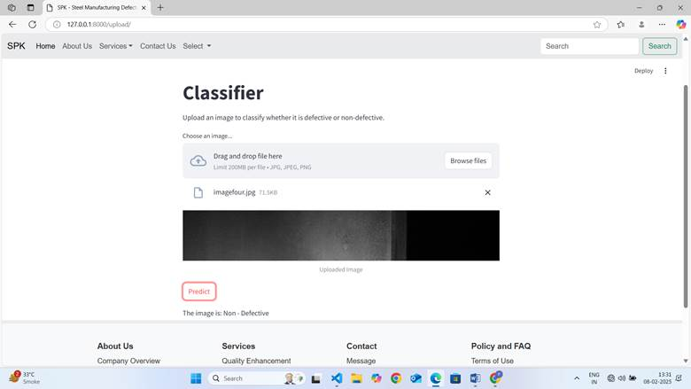
Fig 5.4.6 – Detecting Steel as Non-Defective Page

Figure 5.4.6 shows a web-based classifier interface for detecting defects in steel manufacturing. An image has to be uploaded, so that the system can predict that image is "Non-Defective." The interface includes a "Predict" button and a drag-and-drop file upload section.

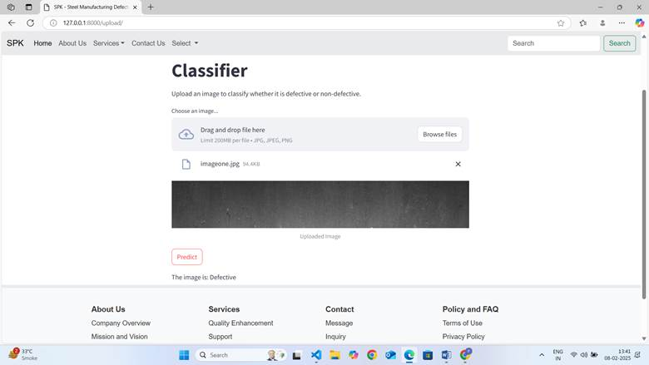
Fig 5.4.7 – Detecting Steel as Defective Page

Figure 5.4.7 shows a web-based classifier interface for detecting defects in steel manufacturing. An image has to be uploaded, so that the system can predict that image is "Defective." The interface includes a "Predict" button and a drag-and-drop file upload section
5.3 Impact Analysis
The Steel Manufacturing Defect Detection project brings a significant and far-reaching impact on the entire steel production lifecycle. Traditional methods of manual inspection are slow, error-prone, and unable to keep pace with modern production demands. By deploying advanced AI models like ResNet50, CNN, and ResUNet, our system automates the detection of defects such as cracks, inclusions, and thickness variations with a high degree of precision and reliability. This automation drastically reduces human error, inconsistencies, and subjectivity in inspections. Real-time monitoring and analysis of thousands of images enable faster decision-making, allowing quality control teams to identify issues immediately and take corrective actions before defective materials proceed to the next stages of production. As a result, there is a major reduction in production downtime, rework efforts, and material wastage, leading to substantial cost savings and operational efficiency.
Furthermore, the consistent detection of defects enhances the overall quality of steel products, ensuring that only superior-grade materials reach customers. This not only boosts customer satisfaction but also strengthens the manufacturer's reputation in a highly competitive market. Over time, the system accumulates valuable data that enables predictive maintenance strategies, helping factories to anticipate and address potential machine failures and process inefficiencies before they escalate. This proactive approach optimizes manufacturing operations and extends equipment lifespan, further reducing maintenance costs.
The implementation of our AI-based solution also frees up skilled human resources from repetitive inspection tasks, allowing them to focus on higher-value activities like process improvement and innovation. Overall, the project significantly increases production throughput, improves product quality, reduces operational expenses, and positions the manufacturing company as a technology-driven leader in the steel industry. By embracing automation and AI, the project supports a shift toward smarter, more efficient, and sustainable manufacturing practices.

5.4 Sustainability and Scalability Analysis
The Steel Manufacturing Defect Detection system is designed with a strong focus on both sustainability and scalability to ensure long-term impact and adaptability to future demands.

From a sustainability perspective, the system promotes efficient resource utilization by minimizing wastage through early and accurate defect detection. The project also supports sustainable manufacturing by ensuring consistent product quality, thereby reducing the need for excessive raw material extraction and minimizing the carbon footprint. The solution is built using scalable and open-source technologies, ensuring low-cost maintenance, ease of updates, and compatibility with emerging AI advancements. Moreover, regular model retraining with new production data ensures that the defect detection system remains relevant, robust, and highly accurate over time.

In terms of scalability, the architecture is designed to accommodate increasing volumes of data and growing production lines without significant changes to the core system. By utilizing cloud-based infrastructure and modular AI models, the system can easily be expanded to handle higher-resolution images, additional defect types, and larger factory setups. The flexibility of the platform allows seamless integration with other industrial IoT devices, MES (Manufacturing Execution Systems), or quality control software, making it adaptable across different types and scales of steel manufacturing plants.
Overall, the project not only addresses immediate quality control needs but is also built to evolve with advancements in technology, ensuring long-term sustainability, adaptability to industrial growth, and readiness for future innovation in the steel manufacturing sector.

CHAPTER 6

CONCLUSION AND FUTURE WORK

6.1 Conclusion
In the "Steel Manufacturing Defects" project, leveraging advanced models such as ResNet50, ResUNet for segmentation, and Convolutional Neural Networks (CNN) will significantly enhance defect detection accuracy. ResNet50, known for its deep residual learning capabilities, is effective in extracting features from complex images, while ResUNet excels in pixel-level segmentation, allowing for precise localization of defects within steel products. Combining these models with transfer learning and real-time processing frameworks ensures robust performance across a variety of defect types. The project's objectives are centered on developing an efficient, automated defect detection system that empowers manufacturers to enhance product quality and operational efficiency. By enabling real-time processing, incorporating explainable AI, and implementing adaptive lighting control, the system will provide immediate insights into defect presence, location, and type. These capabilities not only optimize production processes and resource utilization but also foster data-driven decision-making, leading to improved customer satisfaction and a stronger competitive edge in the market. Ultimately, the integration of these technologies will drive significant advancements in the steel manufacturing sector, promoting sustainable practices and ensuring the delivery of high-quality products.

6.2 Future Work
- Transfer Learning: Transfer learning leverages pre-trained models like ResNet or VGG, fine-tuned for defect detection in steel manufacturing. By utilizing generalizable features learned from vast datasets, this approach reduces the need for extensive training data and time while improving detection accuracy across a wider range of defects, including rare types.
- Real-time Processing: Utilizing real-time processing frameworks such as NVIDIA’s CUDA or OpenCV enables GPU acceleration for rapid analysis of high-volume data streams. This ensures defects are detected instantly, allowing for immediate corrective actions and minimizing production delays.
- Explainable AI (XAI): Incorporating Explainable AI (XAI) offers insights into the model's decision-making process, showing which features or image regions influenced defect classification. XAI improves transparency, helping engineers identify potential model weaknesses and fostering trust in AI decisions.
- Adaptive Lighting Control: Adaptive lighting systems adjust in real-time to ensure consistent image quality under varying environmental conditions. This helps maintain optimal clarity for accurate defect detection, preventing missed defects due to poor lighting.
CHAPTER 7

REFERENCES
REFERENCES
- XiafuLv, Junhao Xu, Chongqing University of Posts and Telecommunications, College of automation, Chongqing, China, 2023 China Automation Congress (CAC) | 979-83503-0375- 9/23/$3100 ©2023 IEEE | DOI: 10.1109/CAC59555.2023.10450211.
- Emre Guclu, Ilhan Aydın, Erhan Akın Department of Computer Engineering, Fırat Univ- ersity Elazığ, Turkey, 2024 ASU International Conference in Emerging Technologies for Sustainability and Intelligent Systems (ICETSIS) | 979-8-3503-7222-9/24/$31.00 ©2024 IEEE | DOI: 10.1109/ICETSIS61505.2024.10459666.
- Dr. G Uday Kiran, Ms. Srilakshmi V, Sevanth Gajula, T Veditha, Aramandla Sravanthi, DVasavi Reddy, Department of CSE(AI & ML), B V Raju Institute of Technology, Narsapur,Telangana , India, 2024 2nd International Conference on Intelligent Data Communication Technologies and Internet of Things (IDCIoT) | 979-8-3503-27533/24/$31.00 ©2024 IEEE | DOI: 10.1109/IDCIOT59759.2024.10467368.
- Prashant Kumar Uraon, Apurv Verma , Abhishek Badholia, Department of Computer Science & Engineering School of Engineering & IT, MATS University, Raipur, India, 2022, International Conference on Edge Computing and Applications (ICECAA) | 9781-6654-8232-5/22/$31.00 ©2022 IEEE | DOI: 10.1109/ICECAA55415.2022.9936318.
- Didarul Amin, Shamim Akhter, AISIP Lab, Dept. Of Computer Science and Engineering International University Of Business Agriculture And Technology Dhaka, Bangladesh, 2020, IEEE Region 10 Symposium (TENSYMP), 5-7 June 2020.
- Sina Rezaei Aghdam and Ehsan Amid, Department of Electrical Engineering, Amirkabir University of Technology, Tehran, Iran 30332–0250, Mohammad Faghih Imani Dideh Pardaz Saba Co. Isfahan, Iran, 978-1-4577-2119-9/12/$26.00 c2011 IEEE.
- Mohammadreza Yazdchi Department of Biomedical Engineering Faculty of Engineering,University of Isfahan Isfahan, Iran, Mehran Yazdi, Arash Golibagh Mahyari Faculty of Electrical and Computer Engineering Shiraz University, Shiraz, Iran, International Conference on Digital Image Processing, 978-0-7695-3565-4/09 $25.00 © 2009 IEEE, DOI 10.11 09/ICDIP.2009.68.
- Khudhur Al-Khazraji, Sathish Kumar Selva Perumal, Chandrasekharan Nataraj, Asia Pacific University of Technology & Innovation, Kuala Lumpur, Malaysia, 2022 IEEE International Conference on Distributed Computing and Electrical Circuits and Electronics (ICDCECE) | 978-1- 6654-8316-2/22/$31.00 ©2022 IEEE | DOI: 10.1109/ICDCECE10.1
109/ICDCECE53908.2022.9793119.
- Zeina Aboulhosn, Raja Jayaraman, Ahmadmusamih, Khaled Salah(Senior Member, IEEE),Mohamed Omar, Zeyar Ayung(Senior Member, IEEE), Department of Computer Science, Khalifa University of Science and Technology, Abu Dhabi, United Arab Emirates, @2024, The Authors, DOI 10.1109/ACCESS.2024.3430113.
- Chao-Yung Hsu, Taiwan, Bing-Shiou Ho, Li-Wei Kang, National Yunlin University of Science and Technology, Taiwan, 2016 IEEE International Conference on Consumer Electronics-Asia (ICCE-Asia), 978-1-5090-2743-9/16/$31.00 @2016.
- W. Zhao, F. Chen, H. Huang, D. Li, and W. Cheng, “A new steel defect detection algorithm based on deep learning,” Computational Intelligence and Neuroscience, vol. 2021, pp. 113, 2021.
- W.-q. Li, X. YE, Y.-t. ZHAO, and W.-b. WANG, “Strip steel surface defect detection based on improved yoloV3 algorithm,” ACTA ELECTRONICA SINICA, vol. 48, no. 7, p. 1284,2020.
- W. Li, H. Zhang, G. Wang, G. Xiong, M. Zhao, G. Li, and R. Li, “Deep learning based online metallic surface defect detection method for wire arc additive manufacturing, Robotics and Computer-Integrated Manufacturing, vol. 80, p. 102470, 2023.
- A. Saberiranjbar, J. Ren, and M. El-Gindy, “Defect detection methods for industrial product using deep learning techniques: A review,” Algorithms, vol. 16, no. 2, p. 95, 2023.
- B. Tang, L. Chen, W. Sun, and Z.-k. Lin, “Review of surface defect detection of steel products based on machine vision,” IET Image Processing, vol. 17, no. 2, pp. 303–322, 2023.
- B. Abhisheka, S. K. Biswas, and B. Purkayastha, “A comprehensive review on breast cancer detection, classification and segmentation using deep learning,” Archives of Computational Methods in Engineering, pp. 1–30, 2023.
- M. Newton, T. Chowdhury, I. Gravagne, and D. Jack, “Non-destructive valuation of in-plane waviness in carbon fiber laminates using eddy current testing,” Applied Sciences,vol. 13, no. 10, p. 6009, 2023.
- S. A. Singh and K. Desai, “Automated surface defect detection framework using machine vision and convolutional neural networks,” Journal of Intelligent Manufacturing, vol. 34, no. 4, pp. 1995– 2011, 2023.
- Y. Gao, L. Gao, X. Li, and X. Yan, “A semi-supervised convolutional neural networkbased method for steel surface defect recognition,” Robotics and Computer-Integrated Manufacturing, vol. 61, p. 101825, 2020.
- A. Bodrovskiy, Z.-Y. Wang, and H.-Y. M. Liao, “YOLO4: Optimal speed and accuracy of object detection,” arXiv preprint arXiv:2004.10934, 2020.

PUBLICATIONS AND CERTIFICATES
1. International Conference on Emerging Technologies for Sustainable Development 2025



2. 7th International Conference on ADVANCES IN SCIENCE & TECHNOLOGY


PLAGIARISM REPORT

